Faculty of Technology, Arts and Culture (TAC)
Coursework Brief 2025/26
Module name: |  | OO Design and Development
Module code: |  | CTEC2710
Title of the Assignment: |  | JavaFX Module Selector GUI
This coursework item is: (delete as appropriate) |  |  |  | Summative
This summative coursework will be marked anonymously |  |  |  |  |  |  | No
The learning outcomes that are assessed by this coursework are:
- Design and develop applications with emphasis on quality, maintainability, correctness and robustness, enhancing their trustworthiness.
- Evaluate and make effective use of the Software Development Kit Application Programming Interfaces
This coursework is: (delete as appropriate) |  |  | Individual
This coursework constitutes 50% to the overall module mark.
Date Set: | Friday 31st October 2025
Date & Time Due: | Monday 17th November 2025 at midday 12:00 (noon)
In accordance with the University Assessment and Feedback Policy, your marked coursework and feedback will be available to you on: 8/12/2025
You should normally receive feedback on your coursework no later than 15 University working days after the formal hand-in date, provided that you have met the submission deadline
If for any reason this is not forthcoming by the due date your module leader will let you know why and when it can be expected. The Associate Head Education (archie.khuman@dmu.ac.uk) should be informed of any issues relating to the return of marked coursework and feedback.
When completed you are required to submit your coursework to:
- LearningZone VLE through a submission portal. See page 2 of the (following) attached document for further detail.
Late submission of coursework policy:
Late submissions will be processed in accordance with current University regulations.

Please check the regulations carefully to determine what late submission period is allowed for your programme.
Academic Offences and Bad Academic Practices:
Please ensure you read the section entitled “Academic Offences and Bad Academic Practice” in the module handbook or the relevant sections in this BaseCamp link: Overview: Assessment and Good Academic Practices
Tasks to be undertaken: See (following) attached document.
Deliverables to be submitted for assessment: See (following) attached document.
How the work will be marked: See (following) attached document.
Module leader/tutor name: |  | Luke Attwood
Contact details: |  | lattwood@dmu.ac.uk (GH6.71)
JavaFX Module Selector GUI

Objectives

The objective of this assessment is for you to demonstrate your ability to design and implement an OO system consisting of a set of Java classes, using advanced libraries within the Java SDK. In particular:
- To study and correctly make use of a prebuilt student profile data model.
- To build a suitable user interface using JavaFX libraries.
- To implement event handling procedures that provide a basis for an interactive and user-friendly system.
- To adhere to standard principles of the Model-View-Controller (MVC) design pattern and appropriately decompose classes through abstraction and encapsulation.

Submission

Submit your Eclipse project through the submission portal available on LearningZone. You should create a new folder called “CTEC2710Assignment”, copy your Eclipse project into this folder, ensuring all of the Java source files (and any other associated files) are in it. Then compress the folder into a .zip file, which you can submit through LearningZone.

Marking and Feedback

Your work will be marked using a predefined LearningZone VLE Rubric grid, which will display your level of achievement and feedback for each of the assessment criteria for this assignment (shown later in this specification). The categories within the rubric act as a guide and the 'closest fit' will be selected for each individual piece of work, ensuring the overall result is reflective of the DMU Undergraduate Mark Descriptors.

Important Note

Please do NOT be tempted to search the internet for an existing solution and then hand this in – e.g. if you run out of time. This is cheating – it is better to hand in what you have honestly achieved by yourself than try to get credit for someone else’s work and risk getting caught. Cheating is an academic offence.
If you get stuck then please ask the module tutors for assistance and come to the labs – we will be providing help in the labs (but not actually doing it for you of course).
Do NOT use anyone else’s material without referencing it – this is bad academic practice or plagiarism. These are considered as academic offences.
Do NOT work jointly on a solution; do NOT give your solution to anyone else to “help them” and do NOT accept anyone else’s solution as “guidance”. Such practice could lead to an allegation of collusion which is an academic offence. All parties involved in collusion (the givers, the receivers, the collaborators) can be found guilty of an academic offence, irrespective of motive.
JavaFX Module Selector GUI specification

A student profile captures the details of an individual second year undergraduate computing student and allows them to select their final year module options. There are compulsory modules that must be selected (depending on the course of study), and others that are only associated with certain courses. Modules either run in block 1 or 2, or semester 2.

Your task is to build an interactive graphical user interface (GUI) that dynamically allows modules to be selected based on the chosen course of study, and then stores this information. The application should be user-friendly and contain appropriate validation to ensure only a legitimate selection of modules is made.

For this prototype, you are only required to use the data of two courses, Computer Science and Software Engineering. However, the system should be designed such that it would be relatively simple to add further courses and modules in the future.

The table below shows all of the available modules, their credit amount, and whether they are an option or compulsory for Computer Science and Software Engineering students.
Both Computer Science and Software Engineering students have 90 compulsory credits. In total 120 credits must be selected via a legitimate combination of modules.

Both courses start off by studying CTEC3701 in block 1, but each have a different compulsory module in block 2. In the second semester (blocks 3 and 4) students study the project module CTEC3451 alongside their chosen option. There are two options which can be selected by both courses. Computer Science students may exclusively study IMAT3711 and IMAT3722 whilst Software Engineering students may exclusively study CTEC3706.

In this case study, once students have successfully chosen a legitimate optional module as their first preference, they are then required to select one reserve optional module from those that remain. The reserve module can then be used in the unlikely scenario of another module not running or being at full capacity for example.

Code | Title | Credits | Block | Computer Science | Compulsory | Software Engineering | Compulsory
CTEC3701 | Software Development: Methods & Stand | 30 | 1 | x | x | x | x
CTEC3702 | Big Data and Machine Learning | 30 | 2 | x | x
CTEC3703 | Mobile App Development and Big Data | 30 | 2 |  |  | x | x
CTEC3451 | Development Project | 30 | 3/4 | x | x | x | x
CTEC3704 | Functional Programming | 30 | 3/4 | x |  | x
CTEC3705 | Advanced Web Development | 30 | 3/4 | x |  | x
IMAT3711 | Privacy and Data Protection | 30 | 3/4 | x
IMAT3722 | Fuzzy Logic and Inference Systems | 30 | 3/4 | x
CTEC3706 | Embedded Systems and IoT | 30 | 3/4 |  |  | x
Guidance on building the application

You are advised to thoroughly read this guidance and to continually refer to it as a means of helping you design and implement the JavaFX Module Selector GUI application.

Please download ModuleSelector.zip and extract the Java Project, then import it into Eclipse. You will note that it contains a template structure for you to work from including logical packages.

Application Loader

In the main package you have been given an ApplicationLoader that simply instantiates the view (i.e. ModuleSelectorRootPane) and model (i.e. StudentProfile), and passes these to the controller (i.e. ModuleSelectorController).

This should help you get started. You should clearly showcase the MVC design pattern throughout your implementation. You will be assessed on your ability to sensibly decouple these entities to make a maintainable and reusable solution.

The Model

You have been provided with the data model for this application - The model contains four classes – StudentProfile, Course, Module, and Name, and an enum Block.
- A Student Profile encapsulates a student name, p number, email, submission date, a Course of study, and a set of selected Modules, along with a set of reserved Modules.
- A Course has a name and a collection of all Modules available on that course.
- A Module has a code, name, credit amount, is either mandatory or not, and has a block it runs in – either 1, 2 or 3/4.
- A Name for a student is made up of a first name and a family name.

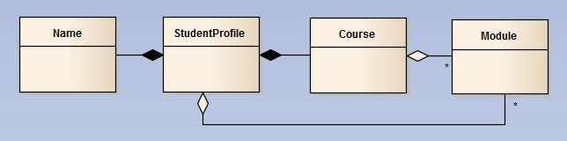

The model classes purposely have no javadoc comments, as you are required to study the source code in order to understand how to use them as the data model for your MVC application. You will not be assessed on writing javadoc for this assignment either.

For the vast majority of this assignment, you will not need to add any further code to the model and are advised to make use of existing methods wherever possible.

The View

In the view package you have been given a root pane, from which you can build your user interface. The GUI is made up of four forms, which should be separated onto different tabs. You have been given the first of these forms (placed onto a tab), along with a menu bar. There are also some methods in these classes to help you get started. The overall GUI should include the following:

Create Profile tab
Displays a combo box, pre-populated with the two aforementioned second year computing courses, and five text fields for inputting a student P number, first and last name, email, and the submission date. There is also a create profile button.

Select Modules tab
Should display two list views for selected block 1 and block 2 modules (for the chosen course), and two further list views for unselected and selected block 3/4 modules. The accumulated credits for the current module selection should be displayed. There should be add and remove buttons for block 3/4 modules, and an overall reset and submit button.

Reserve Modules tab
Should display the remaining unselected block 3/4 modules. A reserve module should be chosen (using unselected/selected list views). There should be add and remove buttons, as well as a confirm button.

Overview Selection tab
Should display an overview of the student’s details, selected modules and reserved module based on their submitted profile and module selection from the previous three tabs. The information should be clear and well-presented across three separate text areas. There should also be a save overview button.

Your GUI also has a menu bar:

The Menu Bar
This Menu bar has two menus: File and Help. The File menu is made up of menu items: “Load Student Data”, “Save Student Data” and “Exit”. The Help menu is made up of a single menu item: “About”.

Note: You are strongly advised to decompose the view by separating logical containers into their own top-level classes, enhancing reusability and abstraction. You will also need to provide suitable methods that allow relevant data to be accessed and modified within the view, adhering to principles of encapsulation and forming a clean public interface.

You can see the Sample GUI screenshots section at the end of this document to assist in visualising how the GUI should generally look and behave, although you may use this as a guide and be creative where applicable.

The Controller

The model and view have been decoupled by deploying a MVC architecture with a separate controller, which will contain the event handlers and general behaviour for this application. To help you get started with this you have been provided with a controller package containing the ModuleSelectorController class. So far, the controller initialises a reference to the view and model, along with its current sub-containers.

You will also notice a method within the controller class called createModulesAndCourses, which populates an array of type Course with the required hardcoded module data. When you load the GUI, the "Create Profile" tab displays a combo box, populated with the two aforementioned computing courses. You will note the addCourseDataToComboBox method undertakes this task.

Event Handling: The remaining key purpose of the controller is to define event handlers. To help you get started you have been given the exit handler along with an empty create student profile handler, which is attached to the create profile pane in the view.

See below details of what each event handler should broadly do. Note there are multiple add and remove handlers required across both the select and reserve modules tabs (please refer to Sample GUI Screenshots). It is also assumed you will consider appropriate validation to aid the behaviour of the application where relevant:
- Create Student Profile Handler - captures the details of the student and stores them within the data model (including their selected course). It should then dynamically populate the select modules tab with the initial unselected and (compulsory) selected modules based on the chosen course.
- Reset Handler - resets the selected modules tab to populate the initial unselected and (compulsory) selected modules based on the current chosen course.
- Add Handlers - removes the current selected module from the unselected modules list view and adds it to the selected (or reserved) modules list view.
- Remove Handlers - removes the current selected module from the selected (or reserved) modules list view and adds it back to the unselected modules list view.
- Submit Handler - captures the details of the selected modules and adds them into the data model. It should then dynamically populate the reserve modules tab with any remaining unselected modules.
- Confirm Handler - captures the details of the reserved module and adds it into the data model. It should then dynamically populate the overview selection tab with an overview of the student’s details, selected modules, and reserved module.
- Save Overview Handler - save an overview of the student's details, as well as their selected and reserved modules in text format using a PrintWriter (or suitable alternative), choosing a custom representation.
- Save Profile Handler - save the student profile (data model) to a file in binary format using an ObjectOutputStream.
- Load Student Data Handler - restore the student profile (data model) from a file using an ObjectInputStream. You should also consider how best to bring the GUI (view) back to its previous state (at the point of saving).
- About Handler - trigger a popup window containing basic details of the application.
- Exit Handler - close the current window and terminate the application.

Note: Whilst you can use the hardcoded module data provided in the controller, a more advanced requirement of the application, would be to use a Scanner to dynamically load the course and module data into the application from a text file. This would allow for the input data to be more easily evolved in the future.

Please turn over...

Assessment Criteria

The following criteria show how you will be assessed:
- User Interface (20%): The user interface appropriately displays and captures all relevant data with a suitable layout.
- Resizing behaviour (10%): There has been consideration of resizing the application using appropriate layout policies. The list views displaying modules and the overview of the selection should all maximize available space both horizontally and vertically.
- Event Handling (20%): The user interface is responsive to interaction and can be used to achieve all associated tasks.
- Fitness for purpose (10%): There is appropriate validation throughout the application to ensure operations behave correctly, and features cannot be misused.
- MVC Design & View Decomposition (30%): The Model-View-Controller (MVC) design pattern has been applied to separate concerns and reduce coupling. The view has had logical containers separated into their own top-level classes, with suitable public interfaces. Abstraction has been applied throughout the design to reduce duplicate functionality and enhance maintainability.
- Saving & Loading (10%): An overview of the student's details and their selected and reserved modules can be written to a file in text form. The current student profile can be saved to a file in binary form and seamlessly restored at a later time. Courses and associated modules can be dynamically pre-loaded into the application from a text file.

Important note: You must develop the GUI using JavaFX (and not any other Java framework such as Swing or AWT). Furthermore, you cannot use a GUI builder of any kind. Failure to meet either of these two requirements will result in an automatic mark of zero for this assignment.

Sample GUI screenshots

These screenshots are provided to help you visualise the core details that the user interface should capture and display. This prototype design is provided as a guide and you do not need to try and replicate the exact layout shown - you may be creative where applicable within the context of the requirements outlined within this specification.

Please turn over to view screenshots...

Default form display
When the application is first loaded, the four forms (of which you have been given the first) will have default appearances, e.g.
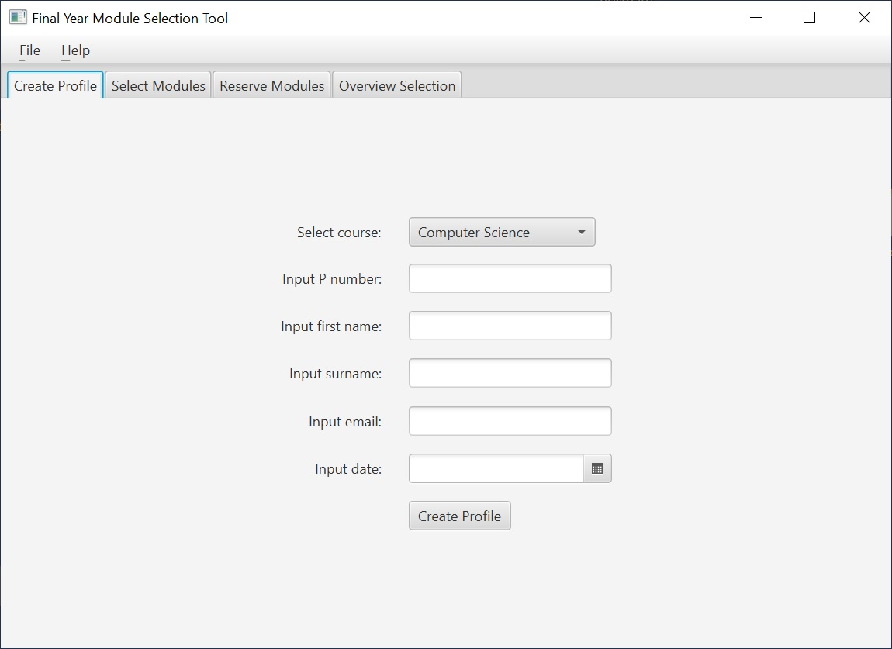

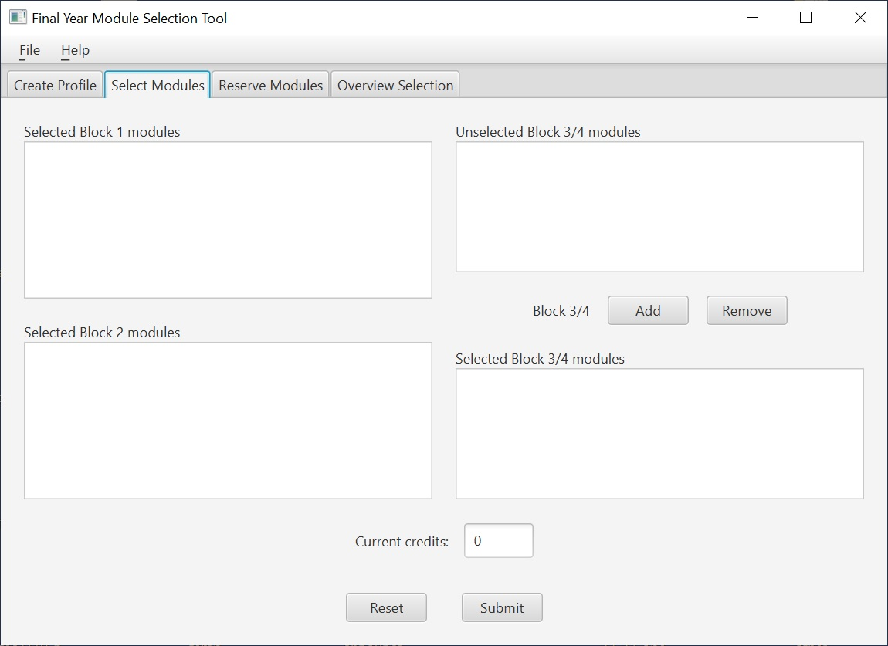
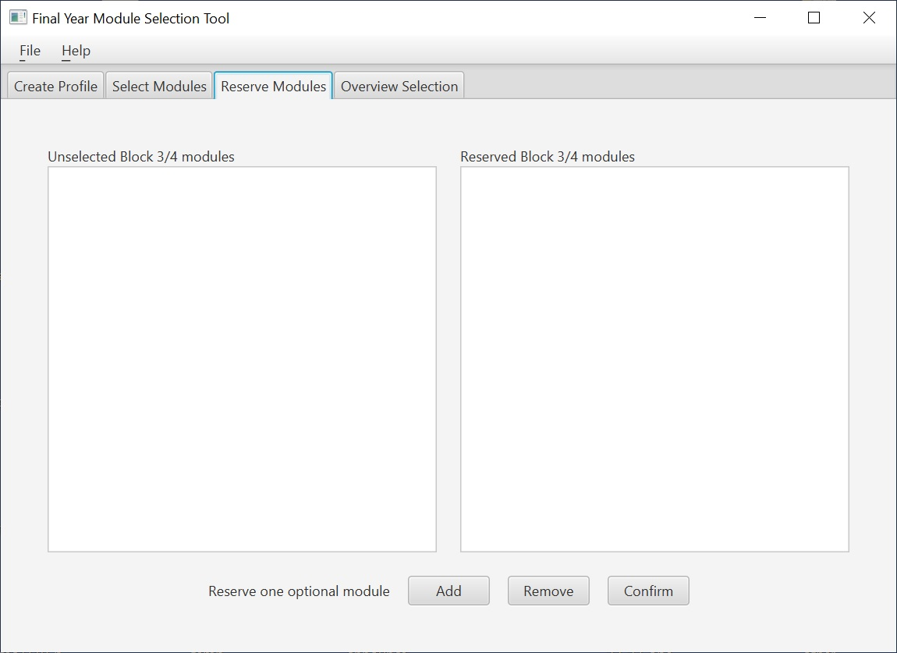

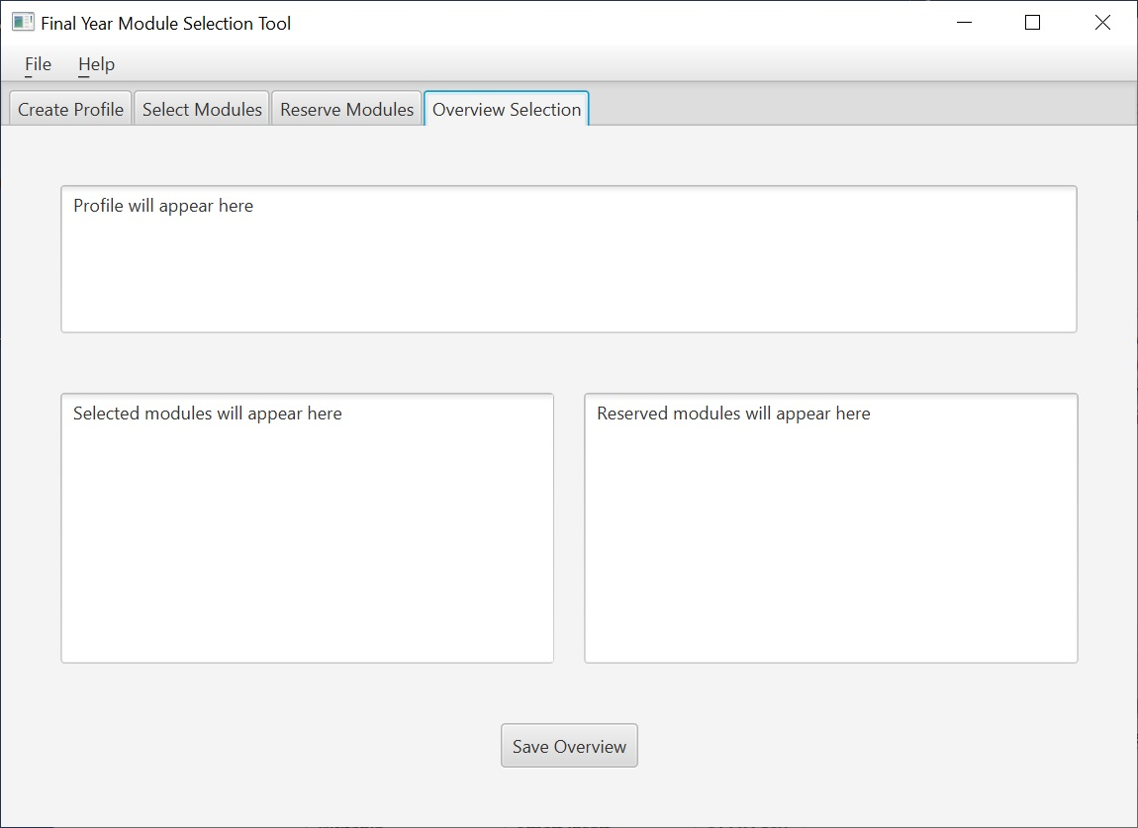

Please turn over…
Using the GUI
A profile is created by selecting a course and inputting student details. The details should be stored in the student profile data model. The select modules form should then be loaded.
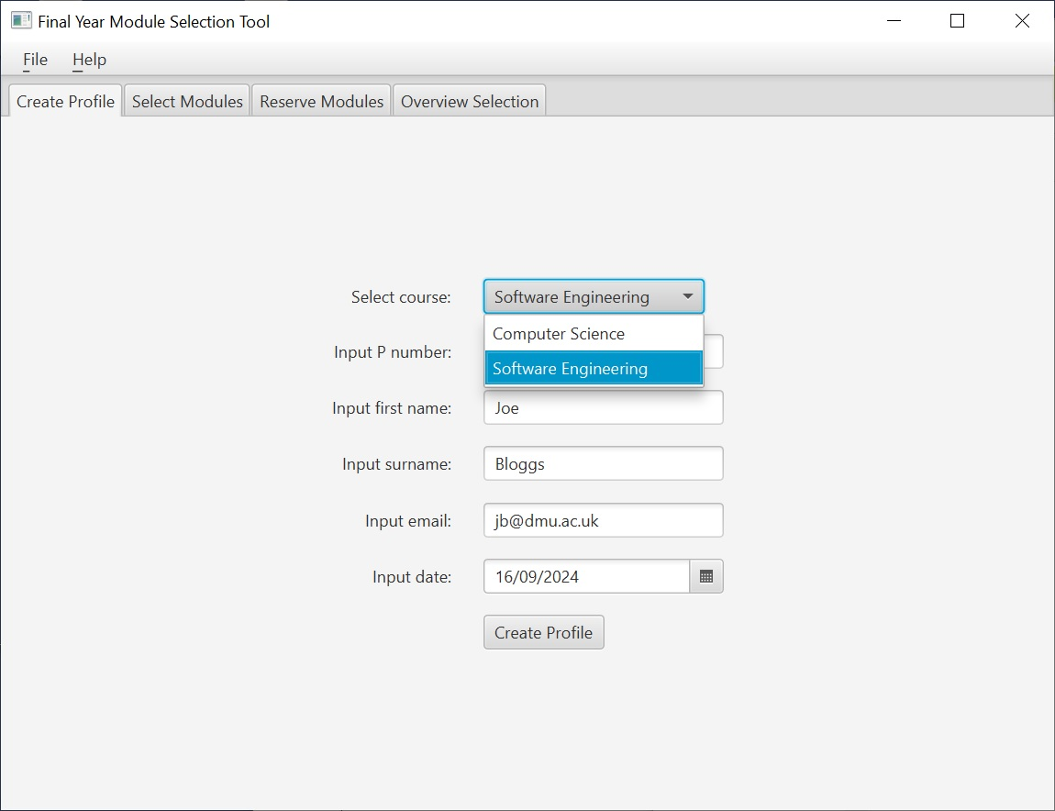
Depending on whether Software Engineering or Computer Science is chosen, associated modules will dynamically populate the select modules form, with the credit amount shown based on the mandatory modules for a given course. You should utilise ListView<Module> controls to capture and display modules on this form.
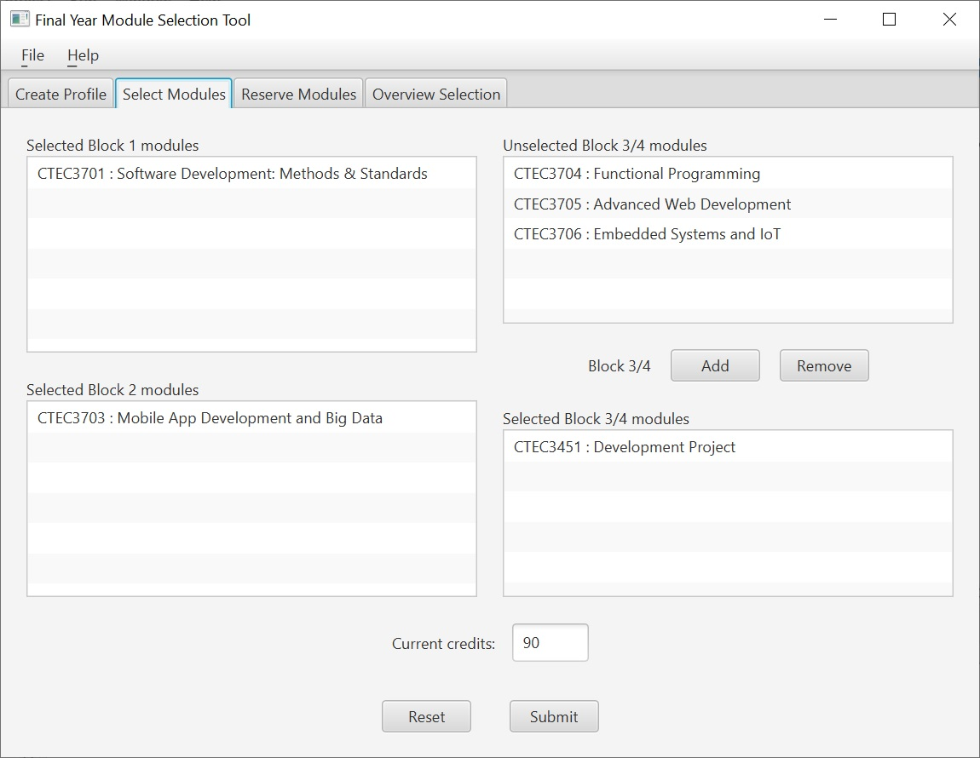
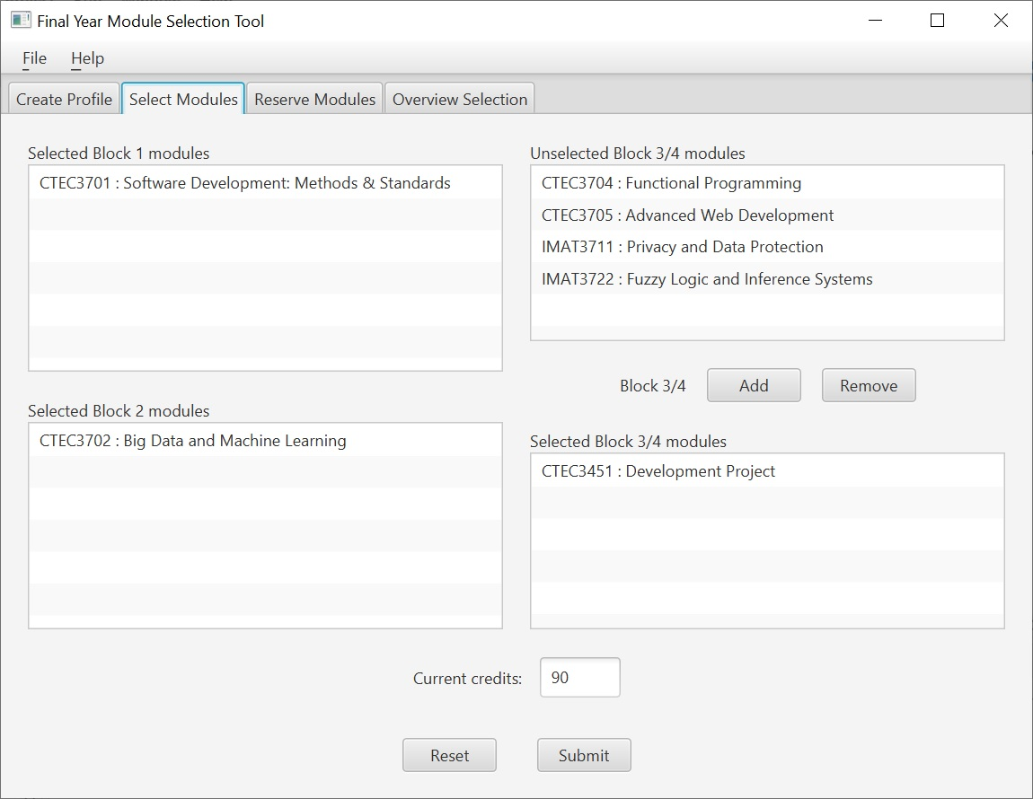
The add/remove buttons allow block 3/4 modules to be chosen. Once 120 credits have been selected you should submit the modules to the student profile model and direct the user to select a reserve module. The reset button should bring this form back to its default state based on the course selected (as shown in previous screenshots).
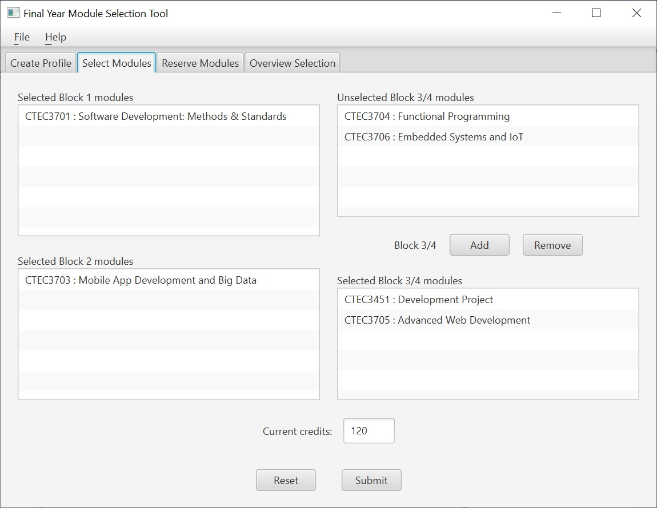

Please turn over…

The reserve modules form should display remaining unselected modules.
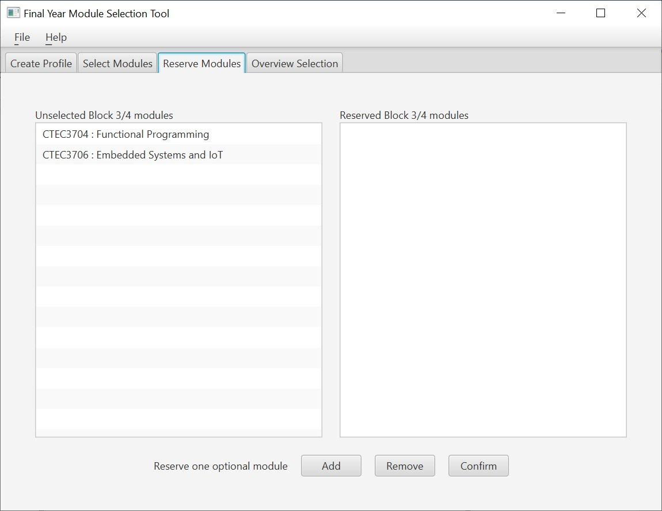
The add/remove buttons allow a module to be reserved
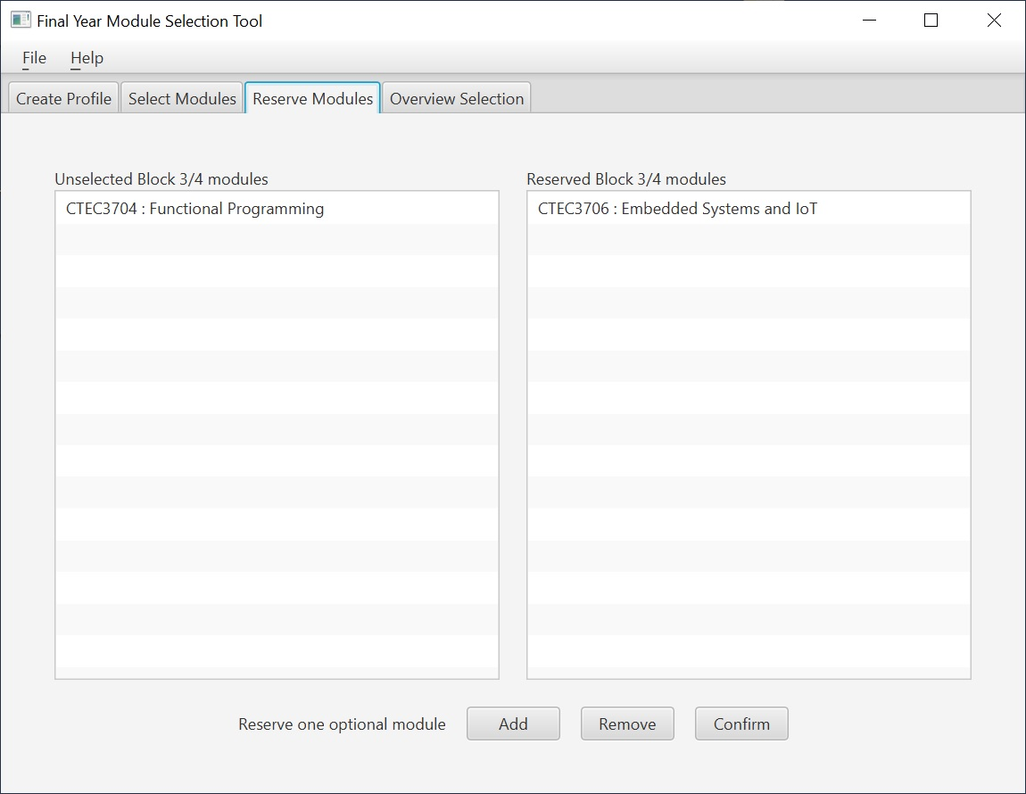
Once a reserve module has been chosen, the confirm button should store the module in the student profile data model. It should then load the overview selection form. An overview of the user’s details, along with their selected and reserved modules should be displayed dynamically using three text areas to maximise space. There is also the ability to save this textual information to a file.
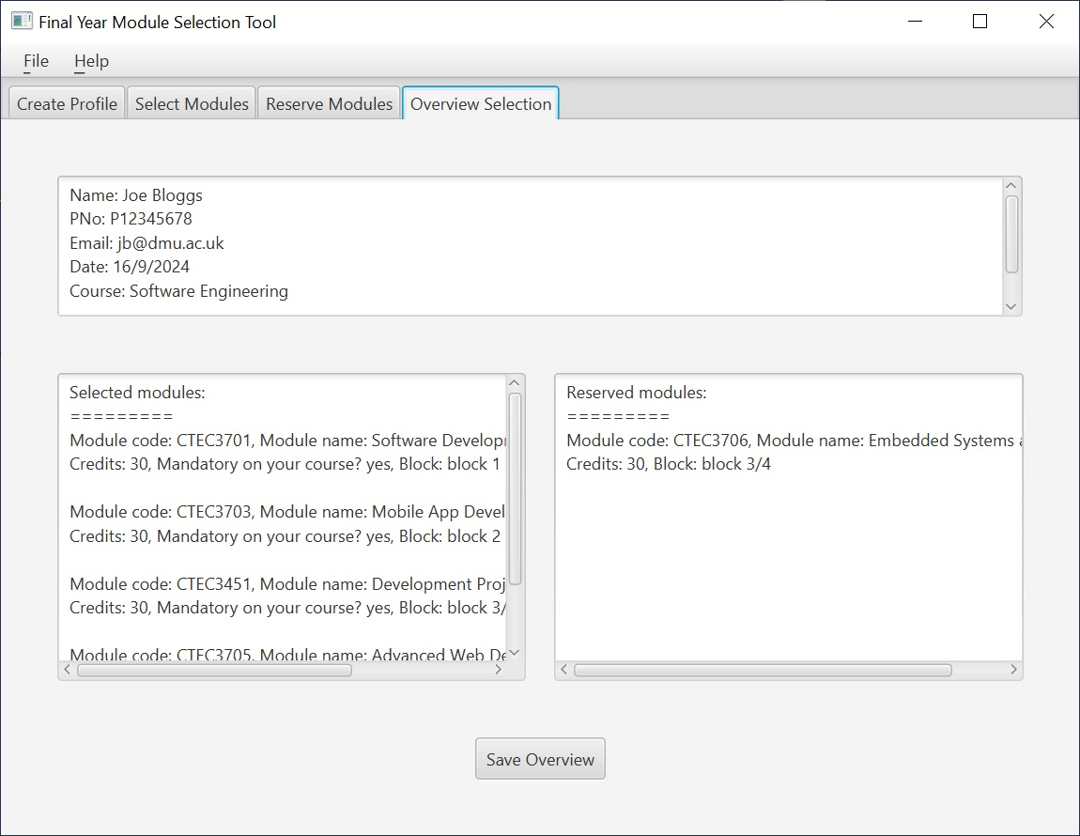

The menu bar
The File menu will allow the data model to be saved to a file in binary form, and restored at a later time, which would load the user interface back to a sensible previous state.
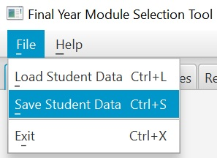

Resizing the GUI
You may impose a sensible minimum size for the stage, but it should be possible to resize it through expansion both horizontally and vertically - there should be no maximum size. Layout policies should be used to maximize the available space in a sensible fashion.
In particular the list views that display modules on the second and third forms should use any spare (horizontal and/or vertical) available space, allowing more information to be seen at a given time. The same applies to the overview shown on the fourth form with respect to the text areas. On the fourth form, the selected and reserved text areas should prioritise space, allowing more modules to be viewed.
The screenshots below provide examples of how the application may resize to maximize any available space in accordance with the aforementioned requirements.
